Project Name: IntelliJ IDEA
Module: Java Project Management
Testing Type: Manual Testing

● Scenario ID: 1a
Scenario: Launch IntelliJ IDEA
Test Steps:
Double-click IntelliJ IDEA

Screenshots:
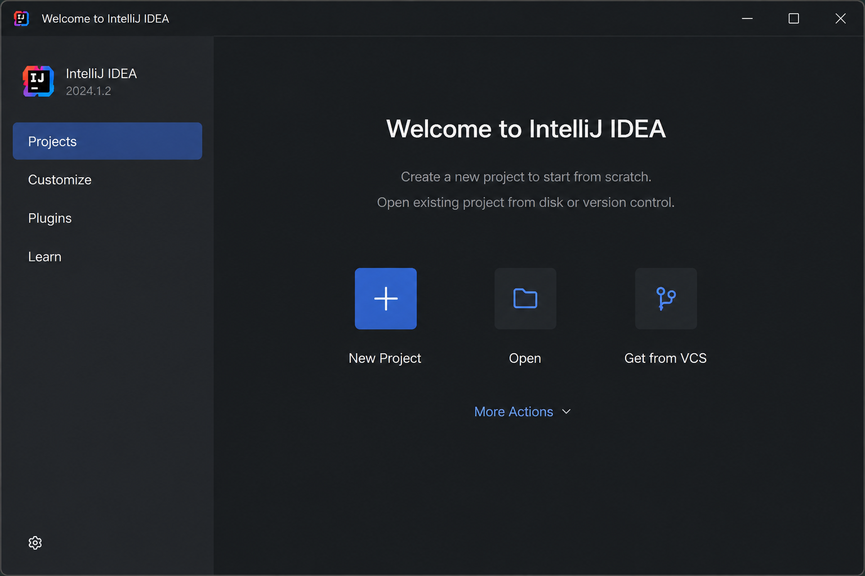

● Scenario ID: 1b
Scenario: Create New Java Project
Test Steps:
File → New Project

Screenshots:
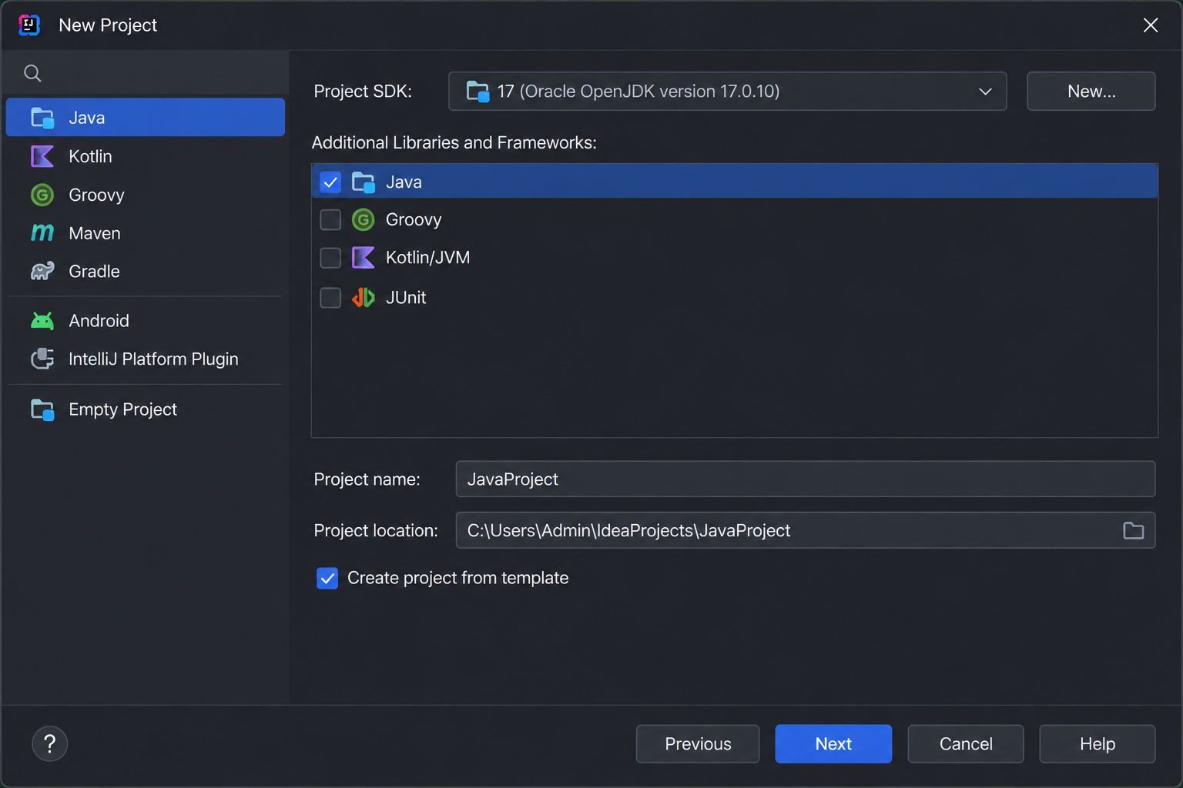

● Scenario ID: 1c
Scenario: Open Existing Project
Test Steps:
File → Open

Screenshots:

● Scenario ID: 2a
Scenario: Create Java Class

Test Steps:
Right-click src → New → Java Class

Screenshots:

● Scenario ID: 2b
Scenario: Write java code

Test Steps:
Enter Java source code

Screenshots:

● Scenario ID: 3a
Scenario: Save Source Code

Test Steps:
Press Ctrl + S

Screenshots:

● Scenario ID: 3b
Scenario: Run Java Program

Test Steps:
Press Ctrl + S

Screenshots:

● Scenario ID: 4a
Scenario: Correct Syntax Error

Test Steps:
Add missing semicolon

Screenshots:

● Scenario ID: 4b
Scenario: Verify Console Output

Test Steps:
Observe Run Console

Screenshots:

● Scenario ID: 5a
Scenario: Debug java program

Test Steps:
Click Debug

Screenshots:

● Scenario ID: 5b
Scenario: Close Project

Test Steps:
File → Close Project

Screenshots:

● Scenario ID: 6a
Scenario: Exit IntelliJ IDEA

Test Steps:
File → Exit

Screenshots:

● Scenario ID: 7a
Scenario: Create New Java Class

Test Steps:
File → New → Java Class → Enter Class Name

Screenshots:

● Scenario ID: 8a
Scenario: Run Java Program with Syntax Error

Test Steps:
Remove semicolon and click Run

Screenshots:

● Scenario ID: 9a
Scenario: Save Project

Test Steps:
File → Save All

Screenshots:

● Scenario ID: 10a
Scenario: Search for a Class

Test Steps:
Press Shift + Shift and search "Student"

Screenshots:

● Scenario ID: 11a
Scenario: Rebuild Project

Test Steps:
Build → Rebuild Project

Screenshots:

